

**DYNAMIC GESTURE RECOGNITION GLOVE**

**A MINIPROJECT REPORT**

***Submitted by***

**T. G. SHANMATHI (913120105030)**

**K. SWETHA (913120105040)**

**K. SWETHA (913120105041)**

***In partial fulfilment for the award of the degree***

***of***

**BACHELOR OF ENGINEERING**

***in***

**ELECTRICAL AND ELECTRONICS ENGINEERING**

**VELAMMAL COLLEGE OF ENGINEERING AND TECHNOLOGY,(AUTONOMOUS)**

**MADURAI-625 009**

**ANNA UNIVERSITY:: CHENNAI 600 025**

**MAY 2023**

## ANNA UNIVERSITY: CHENNAI 600 025

## 

## BONAFIDE CERTIFICATE

## 

Certified that is report **“DYNAMIC GESTURE RECOGNITION GLOVE”** is the Bonafide work of **T. G. SHANMATHI (913120105030), K. SWETHA (913120105040)** and **K. SWETHA (913120105041)** who carried out the Mini project under my supervision.

##### **SIGNATURE SIGNATURE**

##### 

**Dr.R.NARMATHA BANU, M.E.,Ph.D., Dr.B.KIRUTHIGA,MBA.,M.E.,Ph.D.**

##### Head of the Department Assistant Professor - I

Electrical and Electronics Engineering, Electrical and Electronics Engineering, Velammal College of Engineering and Velammal College of Engineering and Technology, Technology,

Madurai–625009. Madurai –625009.

Certified that the candidate was examined on the Viva-Voce Examination held at Velammal College of Engineering and Technology, Madurai on .

**INTERNAL EXAMINER EXTERNAL EXAMINER**

**ACKNOWLEDGEMENT**

First of all, we thank the Almighty for strengthening us throughout the Mini project and helping us to complete it successfully.

We find immense pleasure to convey our sincere thanks to our honourable Principal **Dr. P. ALLI,** for providing necessary facilities in carrying out our project work in our campus.

We would like to express our hearty thanks to our Head of the Department **Dr.R.NARMATHA BANU, M.E., Ph.D.,** for her constant encouragement.

We take this opportunity to express our sincere and heartfelt thanks to our guide, **Dr. B. KIRUTHIGA, MBA, M.E., Ph.D.,** for her patient guidance, timely suggestion technical and moral support and the immense part of her dedication in completing the project work successfully.

We express our special thanks to other staff members of our department, the non-teaching staff and our friends who assisted us, by their support and encouragement.

We also express our special thanks to our Parents who have sacrificed greatly in our education and welfare. We thank all those who have helped directly and indirectly in doing this project and bringing out this successful report.

**TABLE OF CONTENTS**

|  |  |  |
| --- | --- | --- |
| **CHAPTER** | **TITLE** | **PAGE NO** |
|  | **ABSTRACT** | 1 |
| **1** | **INTRODUCTION** | 2 |
| 1.1 | Microcontroller | 3 |
| **2** | **LITERATURE SURVEY** | 5 |
| **3** | **PROBLEM IDENTIFICATION** | 8 |
| 3.1 | Existing System | 8 |
| 3.2 | Objective | 8 |
| **4** | **PROPOSED SYSTEM** | 9 |
| 4.1 | Introduction | 9 |
| 4.2 | Block Diagram | 9 |
| 4.3 | Flow Diagram | 11 |
| 4.4 | Circuit Diagram | 12 |
| **5** | **METHODOLOGY** | 13 |
| 5.1 | System Requirements | 13 |
| 5.1.1 | Hardware Requirement | 13 |
| 5.1.1.1 | Microcontroller | 13 |
| 5.1.1.2 | MP3 module | 15 |
| 5.1.1.3 | Flexi Force Sensor | 20 |
| 5.1.1.4 | Voltage Divider | 21 |
| 5.1.1.5 | Battery | 24 |
| 5.1.1.6 | LED Display | 26 |
| 5.1.1.7 | Arduino Nano | 26 |
| 5.1.1.8 | Speaker | 28 |
| 5.2 | Software Required | 29 |
| 5.2.1 | Arduino IDE | 29 |
| 5.2.2 | Arduino Configurations | 29 |
| 5.2.3 | Arduino Program | 31 |
| **6** | **RESULTS AND DISCUSSION** | 36 |
| 6.1 | Results | 36 |
| 6.2 | Cost Estimation | 38 |
| 6.3 | Advantages | 38 |
| **7** | **CONCLUSION AND FUTURE SCOPE** | 39 |
| **8** | **REFERENCE** | 40 |

**ABSTRACT**

This project is based on the need of developing an electronic device that can translate finger gesture into text or speech in order to make the communication take place between the mute communities with the normal people. A data glove is used to convey the finger gesture of a mute person. The data glove is normal rubber or cloth glove, fitted with flex sensors along the length of each finger. Mute people can use the glove to perform hand gesture and the same will be converted into text as well as in speech so that normal people can understand the mute person expression. This device contains a set of 5 flex sensors which give data as input resistance to the microcontroller according to the bending of flex sensors, this resistance is converted into display through a 16 bit LCD display on which the person on the other side with normal abilities can easily read the converted message or if the person is blind can listen the converted message from the speaker or earphones through voice recording and playback device based on MP3 module. This project can also be used as biomedical instrument in hospitals like intensive care unit or operation theatre.

**CHAPTER 1**

**INTRODUCTION**

1. **INTRODUCTION**:

Sign language is a language which instead of acoustically conveyed sound patterns, uses manual communication and body language to convey meaning. This can involve simultaneously combining hand shapes, orientation and movement of the hands, arms or body, and facial expressions to fluidly express a speaker's thoughts. Wherever communities of deaf people exist, sign language will be useful. Sign language is also used by persons who can hear, but cannot physically speak. While they utilize space for grammar in a way that spoken languages do not. Sign languages exhibit the same linguistic properties and use the same language faculty as spoken languages do. Hundreds of sign languages are in use around the world and are at the cores of local deaf cultures. Some sign languages have obtained some form of legal recognition, while others have no status at all. Deaf and dumb people use sign language to communicate with themselves and with common people. It is very difficult for the common people to understand this language. Though they can show their message in writing, it is not conveyable to the illiterate people. Sign language translating equipment helps in conveying their message to the common people. It translates their message in sign form to the normal understandable text or voice form. All over the world there are many deaf and dumb people. They are all facing the problem of communication. Our project is one such effort to overcome this communication barrier by developing a glove which senses the hand movement of the sign language through sensors and translates it into text and voice output.

* 1. **MICROCONTROLLER:**

Even at a time when Intel presented the first microprocessor with the 4004 there was already a demand for microcontrollers: The contemporary TMS1802 from Texas Instruments, designed for usage in calculators, was by the end of 1971 advertised for applications in cash registers, watches and measuring instruments. The TMS 1000, which was introduced in 1974, already included RAM, ROM, and I/O on-chip and can be seen as one of the first microcontrollers, even though it was called a microcomputer. The first controllers to gain really widespread use were the Intel 8048, which was integrated into PC keyboards, and its successor, the Intel 8051, as well as the 68HCxx series of microcontrollers from Motorola. Today, microcontroller production counts are in the billions per year, and the controllers are integrated into many appliances we have grown used to, like

• Household appliances (microwave, washing machine, coffee machine…)

• Telecommunication (mobile phones)

• Automotive industry (fuel injection, ABS…)

• Aerospace industry 7

• Industrial automation

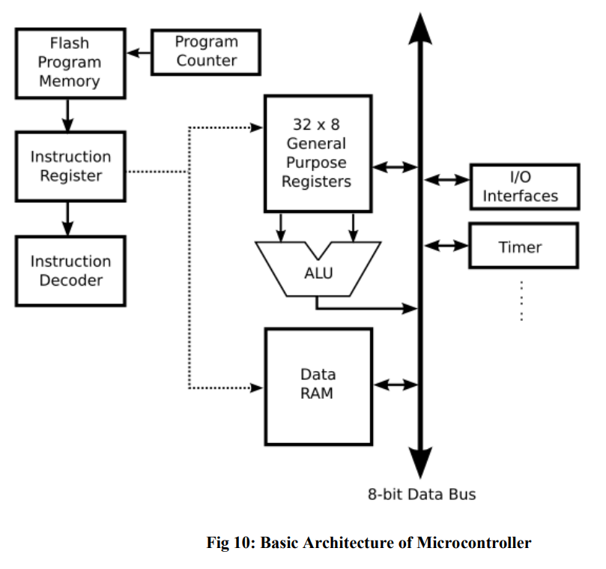

Fig 1.1. Basic Architecture of Microcontroller

**CHAPTER 2**

**LITERATURE SURVEY**

All the reviewed literature describes the system that overcomes the problem faced by the speech and hearing impaired some of them were discussed here:

1. P.B. Koli, Ashwini Chaudhary, Sonam Malkar, Kavita Pawale & Amrapali Tayde, proposed a method using Image Processing Technique. Here, the gestures of alphabets is used to communicate, the webcam captures the exact positions of the alphabets to determine the co-ordinates. The co-ordinates captured is mapped with the one previously stored and accordingly that exact alphabet is produced. Later the word is translated into speech and it will be audible to everyone. Continuing in this way, the deaf and dumb persons can able to go through the entire sentence that they wants to communicate.[1]

2. Harshith.C, Karthik.R. Shastry, Manoj Ravindran, M.V.V.N.S Srikanth, Naveen Lakshmi khanth, proposed a methodology using Gesture recognition which mainly apprehensive on analyzing the functionality of human wits. The main goal of gesture recognition is to create a system which can recognize specific human gestures and use them to convey information or for device control. The approaches present can be mainly divided into Data-Glove Based and Vision Based approaches. An important face feature point is the nose tip. Since nose is the highest protruding point from the face. Besides that, it is not affected by facial expressions. Another important function of the nose is that it 13 is able to indicate the head pose .Knowledge of the nose location will enable us to align an unknown 3D face with those in a face database. [4]

3. Dama Sampath & B. Narsimha Chary, proposed a system in which they used the sensors to measure the parameters of sign language and send the values to the microcontroller. Here MEMS is used in communication with the respective direction of hand movements. The microcontroller gives the voice announcement as the temperature is increases.

4. Dalia Nashat, Abeer Shoker, Fowzyah Al-Swat and Reem Al-Ebailan, proposed a methodology using mobile application. They introduce a Mobile application that enables communication between uneducated Deaf-Dumb and normal people in our society. They also develop an aid tool for deaf and dumb which can be useful in many fields like restaurants, hospitals and transportation. Moreover, their application introduces an easy translator from sign language to English or Arabic language and vice versa[5]

5. Priya Matnani, proposed a technology using hand ,body and facial gestures as a means for interacting with computer sand other physical devices. This paper discusses the rationale for gesture based control technology, methods for acquiring and processing such signals from human operators, applications of these control technologies, and anticipated future developments. The gesture recognition plays an important part of human-machine interaction systems. The focus is done in systems that are based on accelerometers and on glove based equipment.[6]

6. Pragati Garg, Naveen Aggarwal and Sanjeev Sofat. "Vision Based Hand Gesture Recognition" World Academy of Science, Engineering and Technology 49 2009 [2] William T. Freeman, P. A. Beardsley, H. Kage, K. Tanaka, K. Kyuma, C. D. Weissman, "Computer vision for computer interaction" mitsubishi electric research laboratories http://www.merl.com TR99-36 October 1999

7. Fakhreddine Karray, Milad Alemzadeh, Jamil Abou Saleh and Mo Nours Arab," Human-Computer Interaction: Overview on State of the Art" Pattern Analysis and Machine Intelligence Lab., Department of Electrical and Computer Engineering University of Waterloo, Waterloo, Canada international journal on smart sensing and intelligent systems, vol. 1, no. 1, march 2008 [4] Mr. Chetan A. Burande, Prof. Raju M. Tugnayat, Prof.Dr. Nitin K. Choudhary, "Advanced Recognition Techniques for Human Computer Interaction" Information Technology Dept. Jawaharlal Darda Institute of Engg & Tech Yavatmal, India & Shri Bhagavati College of Engg. Nagpur, India

8. M.K. Bhuyan, D. Ghosh and P.K. Bora," Feature Extraction from 2D Gesture Trajectory in Dynamic Hand Gesture Recognition" Department of Electronics and Communication Engineering Indian Institute of Technology Guwahati, India 781039

**CHAPTER 3**

**PROBLEM IDENTIFICATION**

**3.1 EXISING SYSTEM:**

Most data gloves available on the market can cost thousands of pounds, effectively limiting their accessibility to much of their potential target audience. Despite this, completing this research work will demonstrate that the key elements of these systems can be mirrored and even improved upon from our previous work. This project was based around both a robotic hand and a data glove, with more focus on designing and building a real-world hand. The initial requirements were to create both glove and hand with one degree of freedom per finger, and then expanding on that to give more degrees of freedom and control for both. These requirements form the basis of the aims of the project, with each aim representing a milestone towards assembling and testing the data gloves.

**3.2 OBJECTIVE:**

➢ To convert sign language into digital signal.

➢ To store different voice for different signs and supply it to the LED display and Speaker.

➢ To playback voice when particular sign matches through Speaker.

➢ To program and verify the different sign signals.

**CHAPTER 4**

**PROPOSED SYSTEM**

**4.1 INTRODUCTION**

The data glove is normal rubber or cloth glove, fitted with flex sensors along the length of each finger. This device contains a set of 5 flex sensors which give data as input resistance to the microcontroller according to the bending of flex sensors, This resistance is converted into display through a 16 bit LCD display on which the person on the other side with normal abilities can easily read the converted message . If the person is blind can listen the converted message from the speaker or earphones through voice recording .The playback device is based on MP3 module**.**

**4.2 BLOCK DIAGRAM**

The hand gestures are recognized by the Flexi force sensors, the resistance from these sensors are transferred to the Voltage divider. Each finger has individual Flexi force sensor and each sensor has individual voltage divider. The output from the voltage divider is given to the Arduino Nano which is pre-programmed with many number of sign languages. If the hand gesture and the sign languages match, the output is amplified and given to the speaker and LED. The Mp3 module has programmed voice signals for each sign languages.

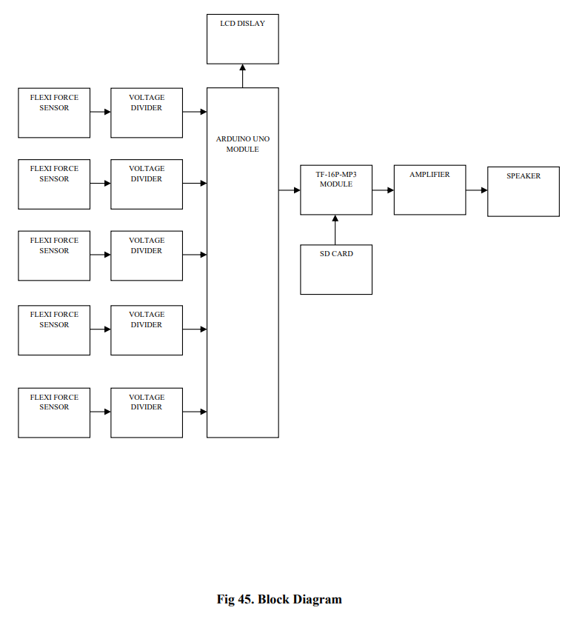

**4.3 FLOW DIAGRAM**

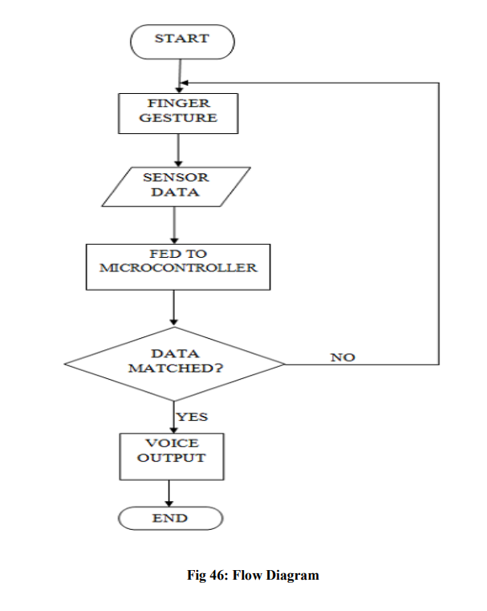

The working of the project for audio output can understand with the help of flow chart as shown above. When a mute person bends his finger, the bending of finger is sensed by the Flex sensor and a corresponding voltage is produced. This sensor data is fed to the microcontroller where analog data is converted to digital data for further processing. After processing if data matched with the stored data then a pre-recorded voice output is listen through speaker, otherwise if data is not matched then the person has to made finger gesture again and process repeats. Microcontroller will send the serial data to the mp3 module along with the track id which is depends upon the given finger sign. Busy pin will used to detect whether last track play has finished or not.

**4.4 CIRCUIT DIAGRAM**

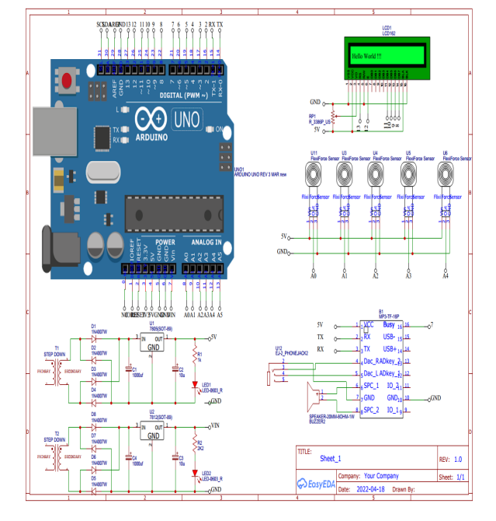

**CHAPTER 5**

**METHODOLOGY**

**5.1 SYSTEM REQUIREMENTS**

The hardware and software requirements for the proposed system are presented as follows:

**5.1.1 HARDWARE REQUIREMENTS**

➢ Microcontroller

➢ MP3 module

➢ Flexi force sensor

➢ Voltage divider

➢ Battery

➢ LED Display

➢ Arduino Nano

➢ Speaker

**5.1.1.1 MICROCONTROLLER**

A microcontroller is a complete microprocessor system built on a single IC. Microcontrollers were developed to meet a need for microprocessors to be put into low-cost products. Building a complete microprocessor system on a single chip substantially reduces the cost of building simple products, which use the microprocessor's power to implement their function, because the microprocessor is a natural way to implement many products. This means the idea of using a microprocessor for low-cost products comes up often. But the typical 8-bit Microprocessor based system, such as one using a Z80 and 8085 is expensive. Both 8085 and Z80 system need some additional circuits to make a microprocessor system. Each part carries costs of money. Even though a product design may require only very simple system, the parts needed to make this system as a low cost product.

To solve this problem microprocessor system is implemented with a single chip microcontroller. This could be called microcomputer, as all the major parts are in the IC. Most frequently they are called microcontroller because they are used they are used to perform control functions.

The microcontroller contains full implementation of a standard MICROPROCESSOR, ROM, RAM, I/0, CLOCK, TIMERS, and also SERIAL PORTS. Microcontroller also called "system on a chip" or "single chip microprocessor system" or "computer on a chip".

A microcontroller is a Computer-On-A-Chip, or, if you prefer, a single-chip computer. Micro suggests that the device is small, and controller tells you that the device' might be used to control objects, processes, or events. Another term to describe a microcontroller is embedded controller, because the microcontroller and its support circuits are often built into, or embedded in, the devices they control.

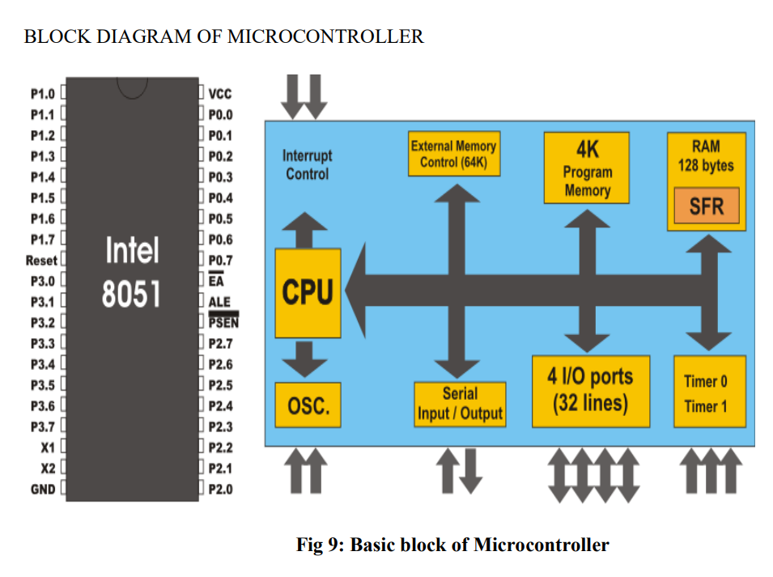

Fig 5.1 Basic Block of Microcontroller

**5.1.1.2 MP3 MODULE**

**Brief Instruction**

DFP Layer Mini module is a serial MP3 module provides the perfect integrated MP3, WMV hardware decoding. While the software supports TF card driver, supports FAT16, FAT32 file system. Through simple serial commands to specify music playing, as well as how to play music and other functions, without the cumbersome underlying operating, easy to use, stable and reliable are the most important features of this module.

**Features**

➢ Support Mp3 and WMV decoding

➢ Support sampling rate of 8KHz,11.025KHz, 12KHz, 16KHz,22.05KHz,24KHz,32KHz,44.1KHz,4 8KHz

➢ 24-bit DAC output, dynamic range support 90dB, SNR supports 85dB

➢ Supports FAT16, FAT32 file system, maximum support 32GB TF card

➢ A variety of control modes, serial mode, AD key control mode

➢ The broadcast language spot feature, you can pause the background music being played

➢ Built-in 3W amplifier

➢ The audio data is sorted by folder; supports up to 100 folders, each folder can be assigned to 1000songs

➢ 30 levels volume adjustable, 10 levels EQ adjustable.

**Application**

➢ Car navigation voice broadcast

➢ Road transport inspectors, toll stations voice prompts

➢ Railway station, bus safety inspection voice prompts

➢ Electricity, communications, financial business hall voice prompts

➢ Vehicle into and out of the channel verify that the voice prompts

➢ The public security border control channel voice prompts

➢ Multi-channel voice alarm or equipment operating guide voice

➢ The electric tourist car safe driving voice notices

➢ Electromechanical equipment failure alarm

➢ Fire alarm voice prompts

B The automatic broadcast equipment, regular broadcast.

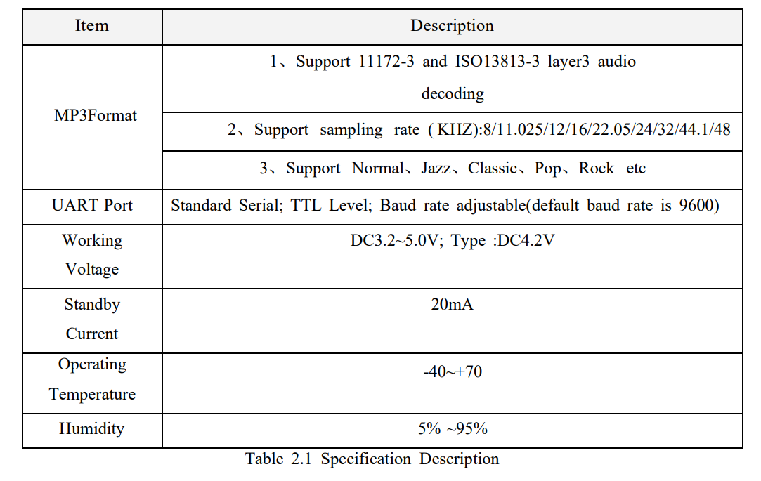 Table 5.1 Specification Description

**Pin Description**

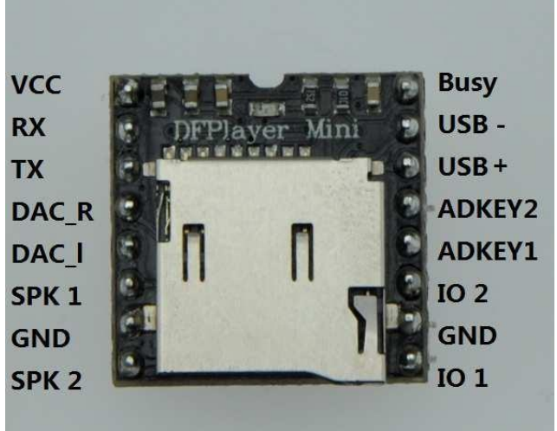

Fig 5.2 Pin Diagram

**Key Ports**

We use the AD module keys, instead of the traditional method of matrix keyboard connection, it is to take advantage of increasingly powerful MCU AD functionality, Our module default configuration 2 AD port, 20 key resistance distribution, if used in strong electromagnetic interference or strong inductive, capacitive load of the occasion.

1. 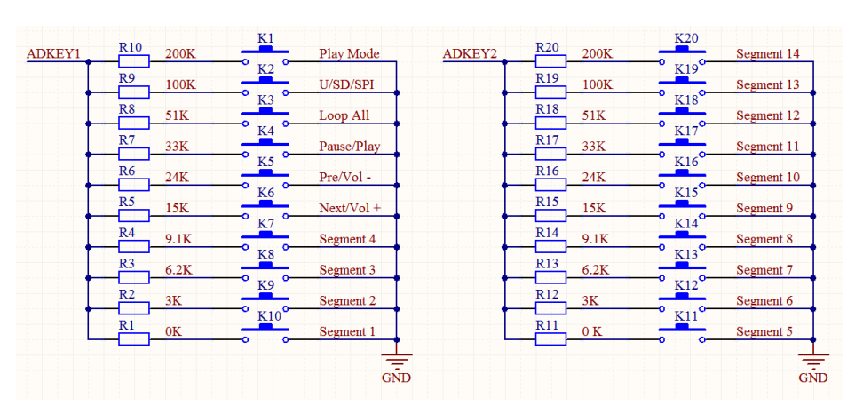Refer diagram

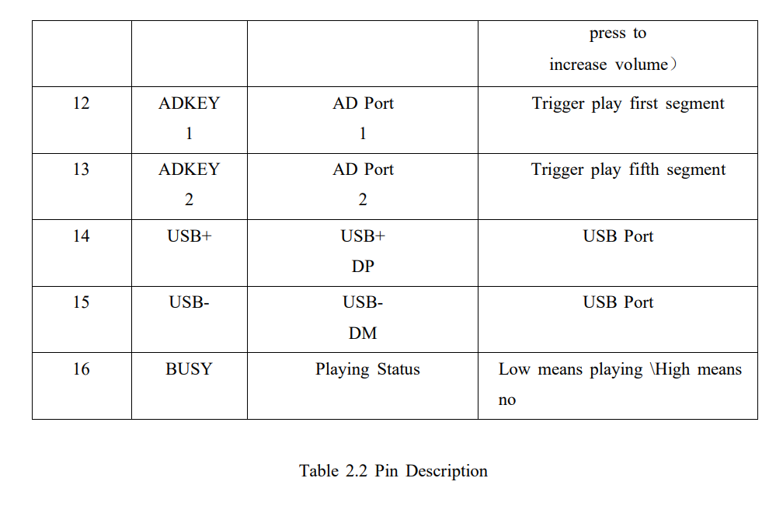 Fig 5.3 Ports

Table 5.2

The module's external interfaces are 3.3V TTL level, so please note the level conversion during the hardware circuit design, also in strong interference environment, electromagnetic compatibility note some protective measures, GPIO using opt coupler isolation, increasing TVS etc.

1. ADKEY key values are in accordance with the general use of the environment, if the strong inductive or capacitive load environment, please note that the module power supply is recommended to use a separate isolated power supply, another matched beads and inductors for power filtering, we must ensure that the input power as 2 much as possible the stability and clean. If you really cannot be guaranteed, please contact us to reduce the number of keys to redefine wider voltage distribution.
2. For general Serial communication, please pay attention to level conversion. If strong interference environment, or long distance RS485 applications, then please note that signal isolation, in strict accordance with industry standard design communication circuits

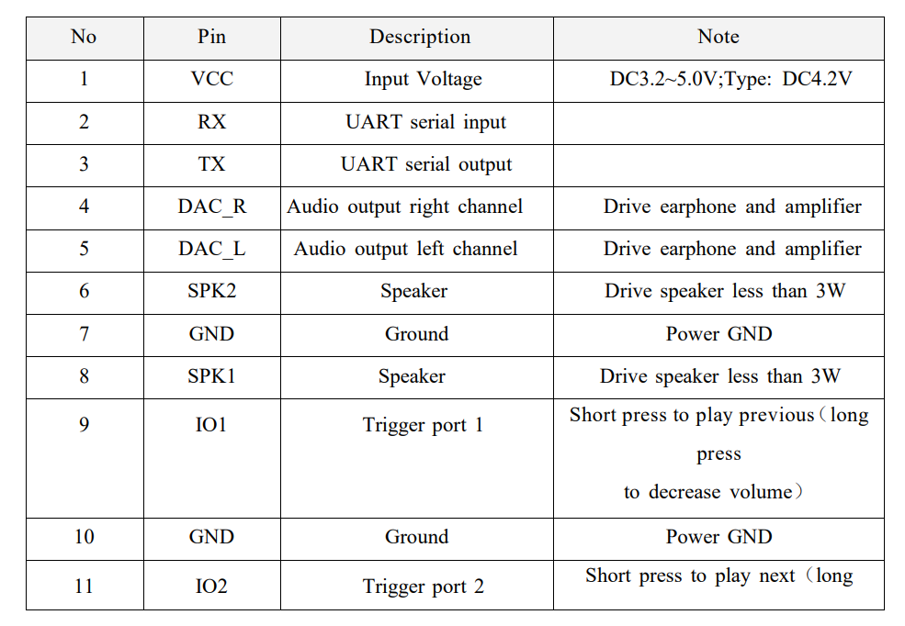

**5.1.1.3 FLEXI FORCE SENSOR:**

Flexi Force tactile force sensors are ultra-thin and flexible printed circuits, which can be integrated easily into force measurement applications. They are typically used to measure the force between any two surfaces.

Flexi Force sensors are perfect for OEM products due to Tekscan’s capacity to customize for an application’s particular needs:

**• Geometry:** Flexi Force sensors can be designed in various shapes and sizes to meet any application and product’s exact needs.

**• Ink technology:** Tekscan supplies three pressure-sensitive ink variations: standard, enhanced and high temperature.

**• Integration support**: Tekscan’s team of mechanical, electrical and application engineers possess vast experience assisting design engineers in helping them realize successful product integration

In an electrical circuit, Flexi Force sensors serve as a force sensing resistor. When the force sensor is unloaded, its resistance is extremely high. When force is applied to the sensor, this resistance is reduced. Any changes in resistance can be customized depending on application requirements.

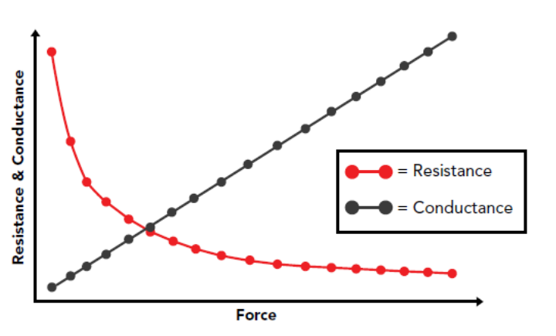

Fig 5.4 Graph

**5.1.1.4 VOLTAGE DIVIDER:**

A voltage divider is a simple circuit consisting of two resistors that has the useful property of changing a higher voltage (Vin) into a lower one (Vout). It does this by dividing the input voltage by a ratio determined by the values of two resistors (R1 and R2)

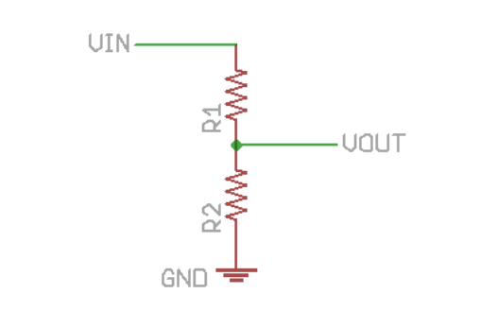

Fig 5.5 Voltage divider

This circuit is best for low-current applications like sensor and data lines. If you draw too much current through Vout it will affect the output voltage. Therefore this shouldn’t be used for high-current applications like power supplies (voltage regulators are a much better option)

To pick resistors, use the following equation:

Vout = Vin R2/(R1 + R2)

You can also find a number of voltage divider calculators using Google.

Because the output voltage depends solely on the ratio of R1 to R2, you could use a number of different R values to get the same output (for example, if R1 = R2, the output will always be half of the input, whether R is 1 Ohm or 1M Ohms). For most of our purposes, the total resistance (R1 + R2) should be between 1k Ohms and 10k Ohms. Less than that and the 5 circuit will waste a lot of power flowing through R1 and R2 to ground. More than that and Vout may not be able to source enough current to drive an analog input.

This circuit is very useful for turning the output from a resistive sensor (such as a thermistor or force-sensitive resistor) into a voltage you can measure using an analog to digital converter. R2 will be your sensor and a good rule of thumb is to choose R1 to be halfway between the lowest and highest resistance values of the sensor.

For example, our Mini Photocell has a light resistance of 1k Ohm, and a dark resistance of 10k Ohm. A 5.6k resistor is just about halfway between the high and low values. If we connect the sensor as R2 and the 5.6k as R1, we get the following Vout

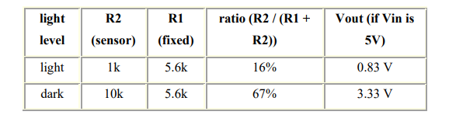

Table 5.4

...so the voltage output will vary from 0.83V in bright light, to 3.33V in the dark. You can't get a complete voltage swing from 0 to 5V without more complex circuitry, but hey, this isn't bad for only one resistor.

A special case of this circuit is a potentiometer, which is a rotary control that allows you to smoothly vary the ratio between R1 and R2, and thus the output voltage, allowing you to create an easy to use analog control.

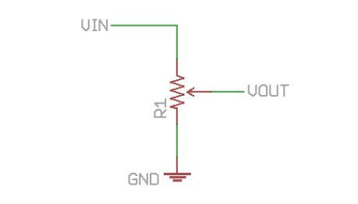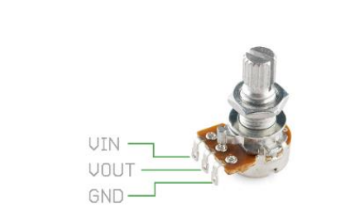

Fig 4.5 Pin Description

Inside a potentiometer is one big resistor with a moving connection (called a "wiper") that can move from one end of the resistor to the other. Electrically, it looks like two resistors, just like in our first schematic above. When you turn the knob, one resistor will get larger while the other will get smaller. To use a potentiometer as a voltage divider, connect your power and ground lines to the outside pins (these are the ends of the big resistor), and use the center pin (the wiper) as your Vout. When you turn the knob, the ratio between the two resistors will change, smoothly varying the output voltage between Vin and GND.

**5.1.1.5 BATTERY:**

A rechargeable battery (also known as a storage battery) is a group of one or more secondary cells Rechargeable batteries use electrochemical reactions that are electrically reversible. Rechargeable batteries come in many different sizes and use different combinations of chemicals. Commonly used secondary cell ("rechargeable battery") chemistries are lead acid, nickel cadmium (NiCd), nickel metal hydride (NiMH), lithium ion (Li-ion), and lithium-ion polymer (Li-ion polymer).

Rechargeable batteries can offer economic and environmental benefits compared to disposable batteries. Some rechargeable battery types are available in the same sizes as disposable types. While the rechargeable cells have a higher initial cost, rechargeable batteries can be recharged many times. Proper selection of a rechargeable battery system can reduce toxic materials sent to landfills compared to an equivalent series of disposable batteries. For example, battery manufacturers of NiMH rechargeable batteries claim a service life of 100-1000 charge cycles for their batteries.

**Usage and applications**

Rechargeable batteries currently are used for applications such as automobile starters, portable consumer devices, light vehicles (such as motorized wheelchairs, golf carts, electric bicycles, and electric forklifts), tools, and uninterruptible power supplies. Emerging applications in hybrid electric vehicles and electric vehicles are driving the technology to reduce cost, reduce weight, and increase lifetime.

Unlike non-rechargeable batteries (primary cells), rechargeable batteries have to be charged before use. The need to charge rechargeable batteries before use deterred potential buyers who needed to use the batteries immediately. However, new low self-discharge batteries allow users to purchase rechargeable battery that already hold about 70% of the rated capacity, allowing consumers to use the batteries immediately and recharge later.

Grid energy storage applications use industrial rechargeable batteries for load leveling, where they store electric energy for use during peak load periods, and for renewable energy uses, such as storing power generated from photovoltaic arrays during the day to be used at night. By charging batteries during periods of low demand and returning energy to the grid during periods of high electrical demand, load- leveling helps eliminate the need for expensive peaking power plants and helps amortize the cost of generators over more hours of operation.

The National Electrical Manufacturers Association has estimated that U.S. demand for rechargeables is growing twice as fast as demand for non- rechargeables.

**Common Rechargeable Battery Types**

**Nickel Cadmium Battery (NiCd)**

Created by Waldemar Jungner of Sweden in 1899 which was based on Thomas Edison's first alkaline battery. Using nickel oxide hydroxide and metallic cadmium as electrodes. Cadmium is a toxic element, and was banned for most uses by the European Union in 2004. Nickel-cadmium batteries have been almost completely superseded by Nickel-metal hydride batteries.

**Nickel-Metal Hydride Battery (NiMH)**

First developed around 1980's. The battery has a hydrogen-absorbing alloy for the negative electrode instead of cadmium.

**Lithium-ion Battery**

The technology behind Lithium-ion battery has not yet fully reached maturity. However, the batteries are the type of choice in many consumer electronics and have one of the best energy-to-mass ratios and a very slow loss of charge when not in use. The popularity of Lithium-ion batteries has spread as their technology continues to improve

**5.1.1.6 LED Display**

A **LED display** is a [flat panel display](https://en.wikipedia.org/wiki/Flat_panel_display) that uses an array of [light-emitting diodes](https://en.wikipedia.org/wiki/Light-emitting_diode) as [pixels](https://en.wikipedia.org/wiki/Pixel) for a [video display](https://en.wikipedia.org/wiki/Video_display). Their brightness allows them to be used outdoors where they are visible in the sun for [store](https://en.wikipedia.org/wiki/Retailing) [signs](https://en.wikipedia.org/wiki/Signage) and [billboards](https://en.wikipedia.org/wiki/Billboard_(advertising)). In recent years, they have also become commonly used in [destination signs](https://en.wikipedia.org/wiki/Destination_sign) on [public transport](https://en.wikipedia.org/wiki/Public_transport) vehicles, as well as [variable-message signs](https://en.wikipedia.org/wiki/Variable-message_sign) on highways. LED displays are capable of providing general [illumination](https://en.wikipedia.org/wiki/Lighting) in addition to visual display, as when used for [stage lighting](https://en.wikipedia.org/wiki/Stage_lighting) or other decorative (as opposed to informational) purposes. LED displays can offer higher contrast ratios than a projector and are thus an alternative to traditional projection screens, and they can be used for large, uninterrupted (without a visible grid arising from the bezels of individual displays) [video walls](https://en.wikipedia.org/wiki/Video_wall). [microLED](https://en.wikipedia.org/wiki/MicroLED) displays are LED displays with smaller LEDs, which poses significant development challenges.[[1]](https://en.wikipedia.org/wiki/LED_display#cite_note-:0-1)

**5.1.1.7 ARDUINO NANO**

The **Arduino Nano** is a small, complete, and breadboard-friendly [board](https://en.wikipedia.org/wiki/Single-board_microcontroller) based on the [ATmega328P](https://en.wikipedia.org/wiki/ATmega328) released in 2008. It offers the same connectivity and specs of the [Arduino Uno](https://en.wikipedia.org/wiki/Arduino_Uno) board in a smaller form factor.[[1]](https://en.wikipedia.org/wiki/Arduino_Nano#cite_note-1)

The Arduino Nano is equipped with 30 male [I/O](https://en.wikipedia.org/wiki/I/O) headers, in a [DIP-30](https://en.wikipedia.org/wiki/Dual_in-line_package)-like configuration, which can be programmed using the [Arduino](https://en.wikipedia.org/wiki/Arduino) Software [integrated development environment](https://en.wikipedia.org/wiki/Integrated_development_environment) (IDE), which is common to all Arduino boards and running both online and offline. The board can be powered through a [type-B mini-USB](https://en.wikipedia.org/wiki/USB_hardware#Connectors) cable or from a 9 V battery.[[2]](https://en.wikipedia.org/wiki/Arduino_Nano#cite_note-2)

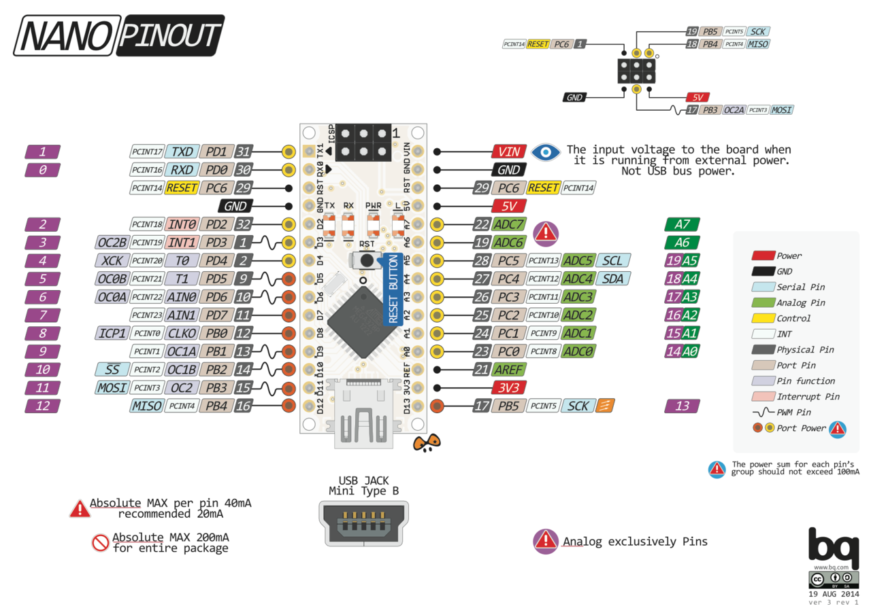

Fig 4.6 Arduino Nano

The Arduino Nano has a number of facilities for communicating with a computer, another Arduino, or other microcontrollers. The ATmega328 provides [UART](https://en.wikipedia.org/wiki/UART) [TTL serial](https://en.wikipedia.org/wiki/TTL_serial) (5V) communication, which is available on digital pins 0 (RX) and 1 (TX).

An FTDI FT232RL on the board channels this serial communication over USB and the FTDI drivers (included with the Arduino firmware) provide a virtual com port to software on the computer. The Arduino software includes a serial monitor which allows simple textual data to be sent to and from the Arduino board. The RX and TX LEDs on the board flash when data is being transmitted via the FTDI chip and the USB connection to the computer (but not for serial communication on pins 0 and 1). A SoftwareSerial library allows for serial communication on any of the Nano's digital pins. The ATmega328 also supports I2C and SPI communication. The Arduino software includes the Wire library to simplify use of the I2C bus.[[4]](https://en.wikipedia.org/wiki/Arduino_Nano#cite_note-website-4)

**5.1.1.8 SPEAKER**

A **loudspeaker** (commonly referred to as a **speaker** or **speaker driver**) is an [electroacoustic](https://en.wikipedia.org/wiki/Acoustical_engineering#Electroacoustics) [transducer](https://en.wikipedia.org/wiki/Transducer)[[1]](https://en.wikipedia.org/wiki/Loudspeaker#cite_note-Ballou-1) that converts an electrical [audio signal](https://en.wikipedia.org/wiki/Audio_signal) into a corresponding [sound](https://en.wikipedia.org/wiki/Sound).[[2]](https://en.wikipedia.org/wiki/Loudspeaker#cite_note-Talbot-Smith-2) A *speaker system*, also often simply referred to as a "speaker" or "loudspeaker", comprises one or more such speaker *drivers*, an enclosure, and electrical connections possibly including a [crossover network](https://en.wikipedia.org/wiki/Audio_crossover). The speaker driver can be viewed as a [linear motor](https://en.wikipedia.org/wiki/Linear_motor) attached to a [diaphragm](https://en.wikipedia.org/wiki/Diaphragm_(acoustics)) which couples that motor's movement to motion of air, that is, sound. An audio signal, typically from a microphone, recording, or radio broadcast, is amplified electronically to a power level capable of driving that motor in order to reproduce the sound corresponding to the original unamplified electronic signal. This is thus the opposite function to the [microphone](https://en.wikipedia.org/wiki/Microphone); indeed the *dynamic speaker* driver, by far the most common type, is a linear motor in the same basic configuration as the [dynamic microphone](https://en.wikipedia.org/wiki/Dynamic_microphone) which uses such a motor in reverse, as a [generator](https://en.wikipedia.org/wiki/Electric_generator).

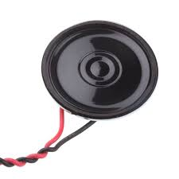

Fig 4.7 Speaker

**5.2 SOFTWARE REQUIREMENTS**

➢ Arduino IDE

**5.2.1 ARDUINO IDE:**

The Arduino integrated development environment (IDE) is a cross-platform application (for Windows, macOS, Linux) that is written in the programming language Java. It is used to write and upload programs to Arduino compatible boards, but also, with the help of 3rd party cores, other vendor development boards.

The source code for the IDE is released under the GNU General Public License, version 2. The Arduino IDE supports the languages C and C++ using special rules of code structuring.

The Arduino IDE supplies a software library from the Wiring project, which provides many common input and output procedures. User-written code only requires two basic functions, for starting the sketch and the main program loop, that are compiled and linked with a program stub main () into an executable cyclic executive program with the GNU toolchain, also included with the IDE distribution.

The Arduino IDE employs the program to convert the executable code into a text file in hexadecimal encoding that is loaded into the Arduino board by a loader program in the board's firmware.

**5.2.2 ARDUINO CONFIGURATION**

➢ Download Arduino IDE from official webpage.

➢ Right click to run on administrator mode.

➢ Click tools select communication port.

➢ If port not visible unplugs the usb cable and replug it.

➢ Click new file.

➢ Select and save destination folder.

➢ Type some code.

➢ Click right symbol button on top left corner to verify your program.

➢ Click the nearest one of right symbol to upload your code into board.

➢ If error occurs select board type and chip. And once the uploading complete it’ll notify the status

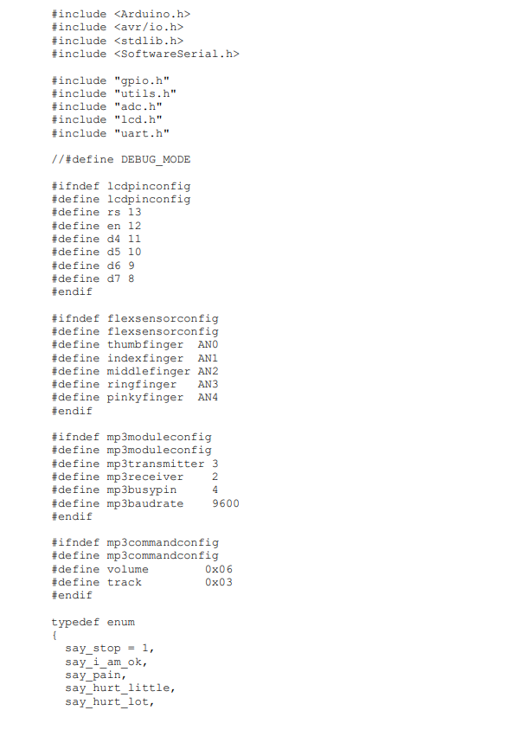**5.2.3 ARDUINO PROGRAM**

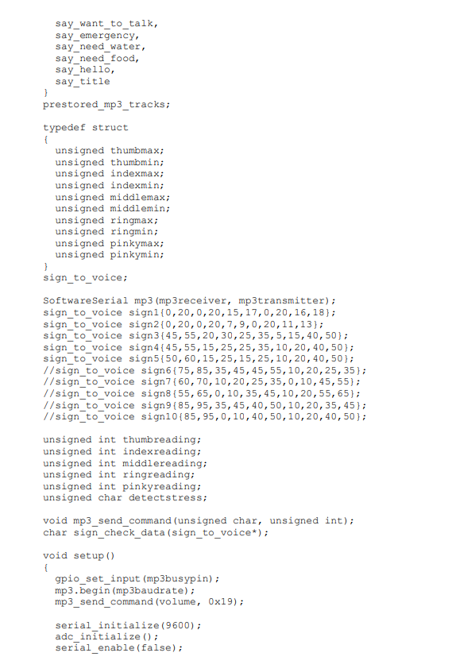

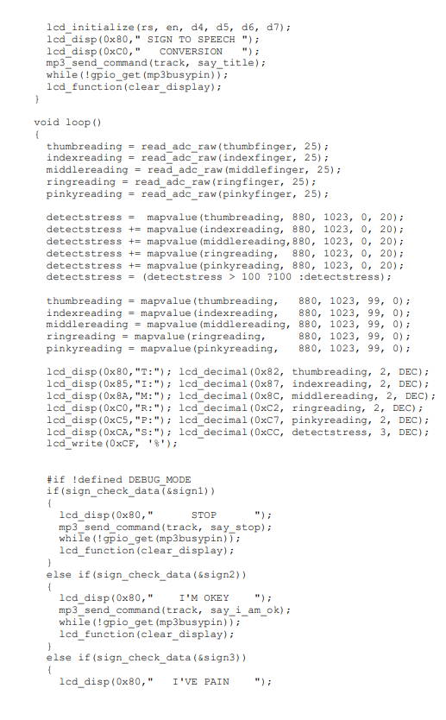

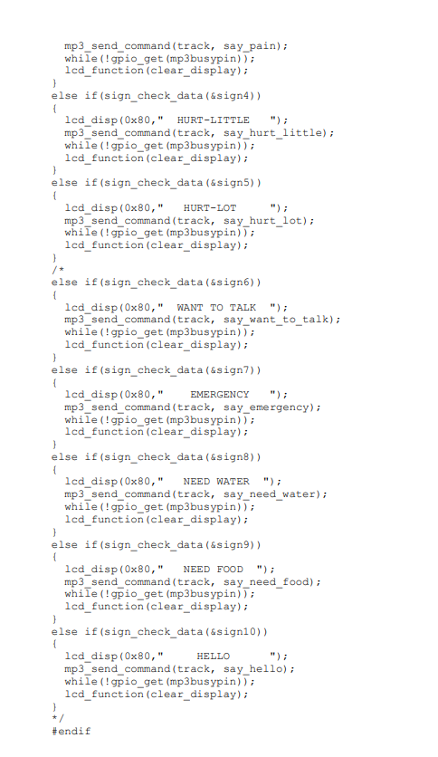

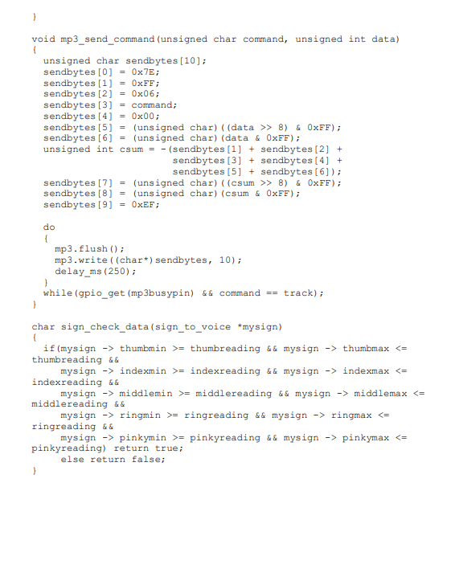

**CHAPTER 6**

**RESULTS AND DISCUSSION**

**6.1 RESULTS**

The Dynamic Gesture Recognition Glove is successfully implemented and explained. This model helps the deaf and dumb people to communicate effectively and efficiently with the common people. All the details about the working and the making of the model is explained. This model can be used Effortlessly.

Fig 6.1 shows the implemented prototype

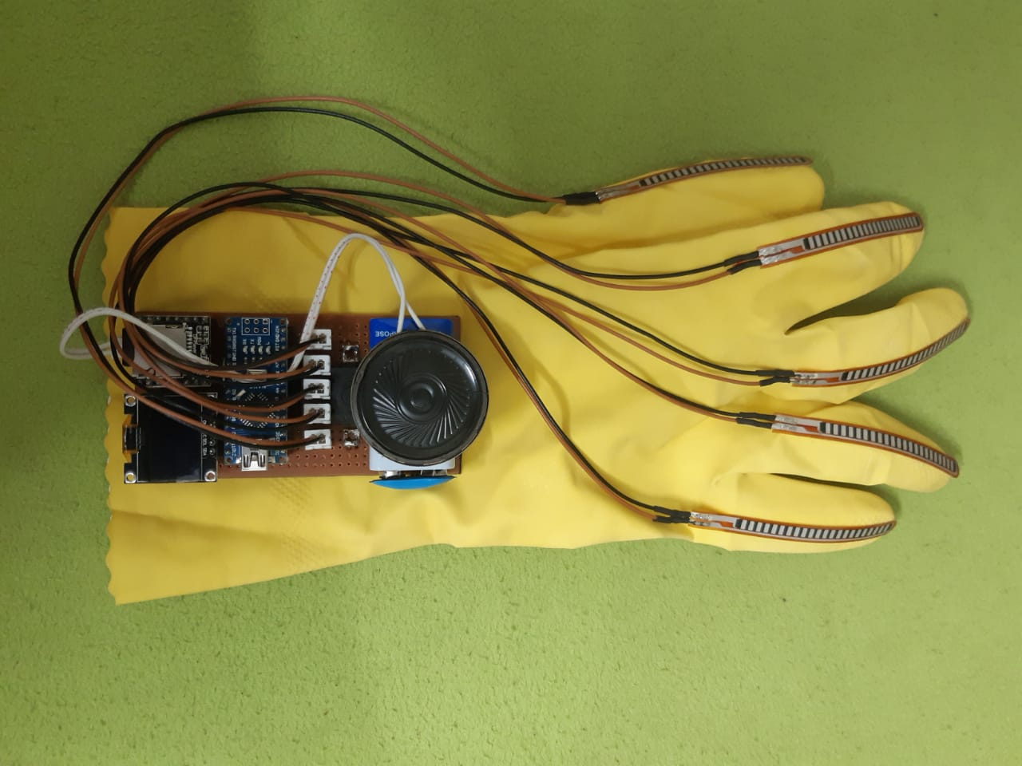

Fig 6.1 Implemented Prototype

Fig 6.2 depicts the working of the prototype.

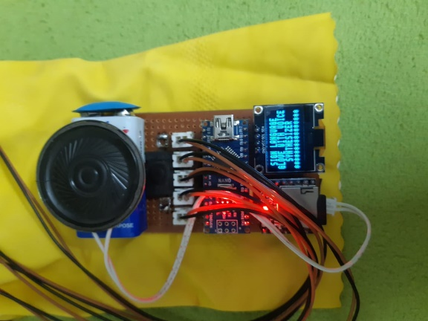

Fig 6.2

Fig 6.3 and 6.4 shows the output of the gesture/sign language.

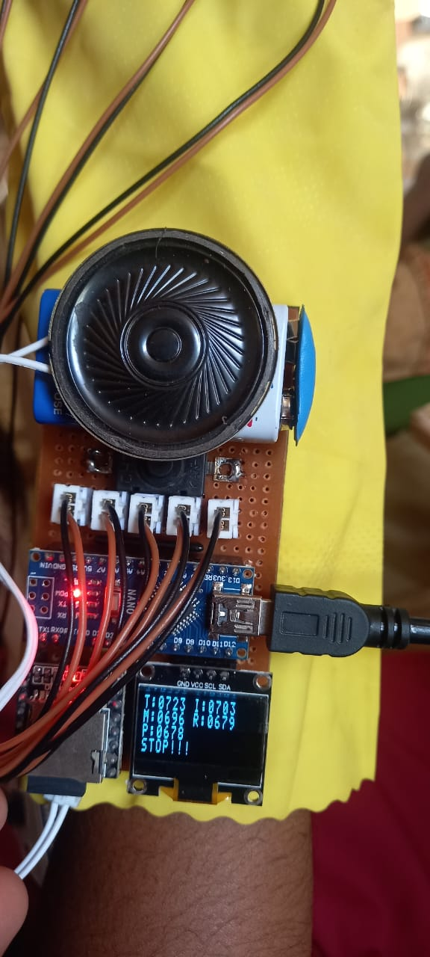 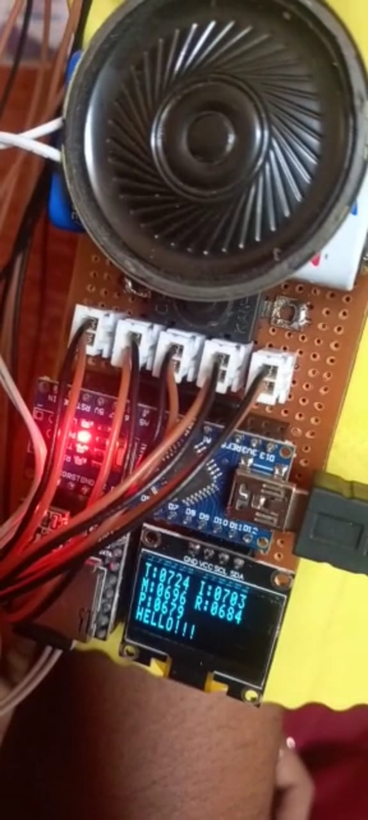

Fig 6.3 Fig 6.4

SIGN - STOP SIGN - HELLO

**6.2 COST ESTIMATION**

|  |  |
| --- | --- |
| **COMPONENTS** | **COST** |
| Arduino Nano | Rs.750 |
| Mp3 Tf 16p Module | Rs 500 |
| 8GB Micro SD Card | Rs 250 |
| 3w/8W Speaker | Rs 400 |
| Flexi Force sensors | Rs 4000 |
| OLED 128*32 | Rs 500 |
| 2*4 Dart Board | Rs 200 |
| Battery | Rs 450 |
| **TOTAL** | **Rs 7050** |

**6.3 ADVANTAGES**

* Easy wearable Device
* Helps Speech Impaired people on daily basis
* Portable
* Simple and Neat compared to Robotic Glove
* Eliminate Man power requirement

**CHAPTER 7**

**CONCLUSION AND FUTURE SCOPE**

Sign language is a very useful to ease the communication between the deaf or mute community and the normal people. Yet there is a communication barrier between these deaf & dumb with normal people. This project aims to overcome the communication gap between the deaf or mute community and the normal world. This project was meant to be a prototype to check the feasibility of recognizing sign language using data gloves. The completion of this project suggests that these data gloves can be used for partial sign language recognition. In future it can support more number of signs and different language mode. We can make this system wireless so that it becomes handy and portable for commercial use. Talking wireless using this we can even transmit the code to a mobile phone. It can also be used for secret military messages. Used to control robotic arms and similar machines. Implemented in Security Systems. Can be extended to aid deaf in communication. By using the voice text Conversion, a deaf and dumb person can easily communicate with normal person.

**CHAPTER 8**

**REFERENCES**

[1].P.B. Koli, AshwiniChaudhary, SonamMalkar, KavitaPawale&AmrapaliTayde “Image Processing Based Language Converter for Deaf and Dumb” IOSR Journal of Electronics and Communication Engineering (IOSR-JECE) e-ISSN: 2278-2834/p-ISSN: 2278-8735 /20-23 Dec 2006/pp. 25-30.

[2].Harshit.C, Karthik.R.Shastry, Manoj Ravindran, M.V.V.N.S Srikanth, Naveen

Lakshmikanth, “Survey on Various Gesture Recognition Techniques for interfacing Machines based on Ambient Intelligence” 2010 International Journal of Computer Science and Engineering Survey, Department of Information Technology, Coimbatore, vol.1, No.2 ,November 2010/pp.31-42.

[3].S.Ganesh, Dr.Saravana Kumar, Dr. Shankar, Samuel D.Raj, R.Kartik, “A Novel Voice Recognition System For Dumb People”, Journal of Theoretical and Applied Information Technology, Vol. 53 No.1/10th July 2013/pp.45-53.

[4].AditiKalsh N.S. Garewal, “Sign Language Recognition for Deaf & Dumb”,

International Journal of Advanced Research in Computer Science and Software

Engineering, Volume 3, Issue 9, September 2013/pp.103-106.

[5].Dalia Nashat, AbeerShoker, Fowzyah Al-Swat and Reem Al-Ebailan, “An Android Application To Aid Uneducated Deaf-Dumb People”, Dalia Nashatet al,

International Journal of Computer Science and Mobile Applications, Vol.2 Issue./ 9 September- 2014/ pp. 1-8

[6].Priya Matnani, “Glove Based and Accelerometer Based Gesture Control : A

Literature Review” 2015 International Journal of Technical Research and

Applications, Department Of Information Technology, Maharashtra, India. Volume 3, issue 6 (November-December,2015)/pp.216- 221.

[7].Sushmita Mitra and TinkuAcharya, ”Gesture Recognition: A Survey”, IEEE

Transactions On Systems, Man, and Cyber- netics—PART C: Applications and

Reviews, VOL. 37, NO. 3, MAY 2007, pp. 311- 324.

[8].Ata-Ur-Rehman, Salman Afghani, MuhammedAkmal and RaheelYousaf,

“Microcontroller and Sensors Based Gesture Vocalizer”, 7th WSEAS International Conference on SIGNAL PROCESSING, ROBOTICS and AUTOMATION (ISPRA)

[9]Lu, Z.; Chen, X.; Li, Q.; Zhang, X.; Zhou, P. A hand gesture recognition framework and wearable gesture-based interaction prototype for mobile devices. IEEE Trans. Hum. Mach. Syst. 2014, 44, 293–299

[10]Patil, S.; Alterovitz, R. Toward automated tissue retraction in robot-assisted surgery. In Proceedings of the 2010 IEEE International Conference on Robotics and Automation, Anchorage, AK, USA, 3–7 May 2010; pp. 2088–2094.

[11]Richard, K.; Reznick, H.M. Changes in the wind. N. Engl. J. Med. 2006, 355, 2664–2669.

[12]Staub, C.; Osa, T.; Knoll, A.; Bauernschmitt, R. Automation of tissue piercing using circular needles and vision guidance for computer aided laparoscopic surgery. In Proceedings of the 2010 IEEE International Conference on Robotics and Automation, Anchorage, AK, USA, 3–7 May 2010; pp. 4585–4590

[13]Wen, R.; Tay, W.L.; Nguyen, B.P.; Chng, C.B.; Chui, C.K. Hand gesture guided robot-assisted surgery based on a direct augmented reality interface. Comput. Methods Programs Biomed. 2014, 116, 68–80.

[15]Pacelli, M.; Caldani, L.; Paradiso, R. Textile piezoresistive sensors for biomechanical variables monitoring. In Proceedings of the 2006 International Conference of the IEEE Engineering in Medicine and Biology Society, New York, NY, USA, 30 August–3 September 2006; pp. 5358–5361.

[16]Jayne, D.G.; Thorpe, H.C.; Copeland, J.; Quirke, P.; Brown, J.M.; Guillou, P.J. Five-year follow-up of the Medical Research Council CLASICC trial of laparoscopically assisted versus open surgery for colorectal cancer. Br. J. Surg. 2010, 97, 1638–1645.

[17]LaRose, D.; Taylor, R.H.; Funda, J.; Eldridge, B.; Gomory, S.; Talamini, M.; Kavoussi, L.; Anderson, J.; Gruben, K. A Telerobotic Assistant for Laparoscopic Surgery. IEEE Eng. Med. Biol. Mag. 1995, 14, 279–288.

[18]Bauzano, E.; Garcia-Morales, I.; del Saz-Orozco, P.; Fraile, J.C.; Muñoz, V.F. A minimally invasive surgery robotic assistant for HALS-SILS techniques. Comput. Methods Programs Biomed. 2013, 112, 272–283. [Google Scholar]. Song, Y.; Demirdjian, D.; Davis, R. Continuous body and hand gesture recognition for natural human-computer interaction. Int. Jt. Conf. Artif. Intell. 2015, 2, 4212-4216.

[19].Ganokratanaa, T.; Pumrin, S. The vision-based hand gesture recognition using blob analysis. In Proceedings of the 2017 International Conference Digital Arts, Media on and Technology (ICDAMT), Chiang Mai, Thailand, 1-4 March 2017; pp. 336-341.

[20]. Asadi-Aghbolaghi, M.; Clapes, A.; Bellantonio, M.; Escalante, H.J.; Ponce-Lopez, V.; Baro, X.; Guyon, I.; Kasaei, S.; Escalera, S. A Survey on Deep Learning Based Approaches for Action and Gesture Recognition in Image Sequences. In Proceedings of the 2017 12th IEEE International Conference on Automatic Face & Gesture Recognition (FG 2017), Washington, DC, USA, 30 May-3 June 2017; pp. 476-483.